Design Document: Low Poly Planets

Specifications of artstyle:

* Must generate awe and wonder.
* Must be grand.
* Ablility to render seemlessly on mobile devices.

Mood board and inspirations:

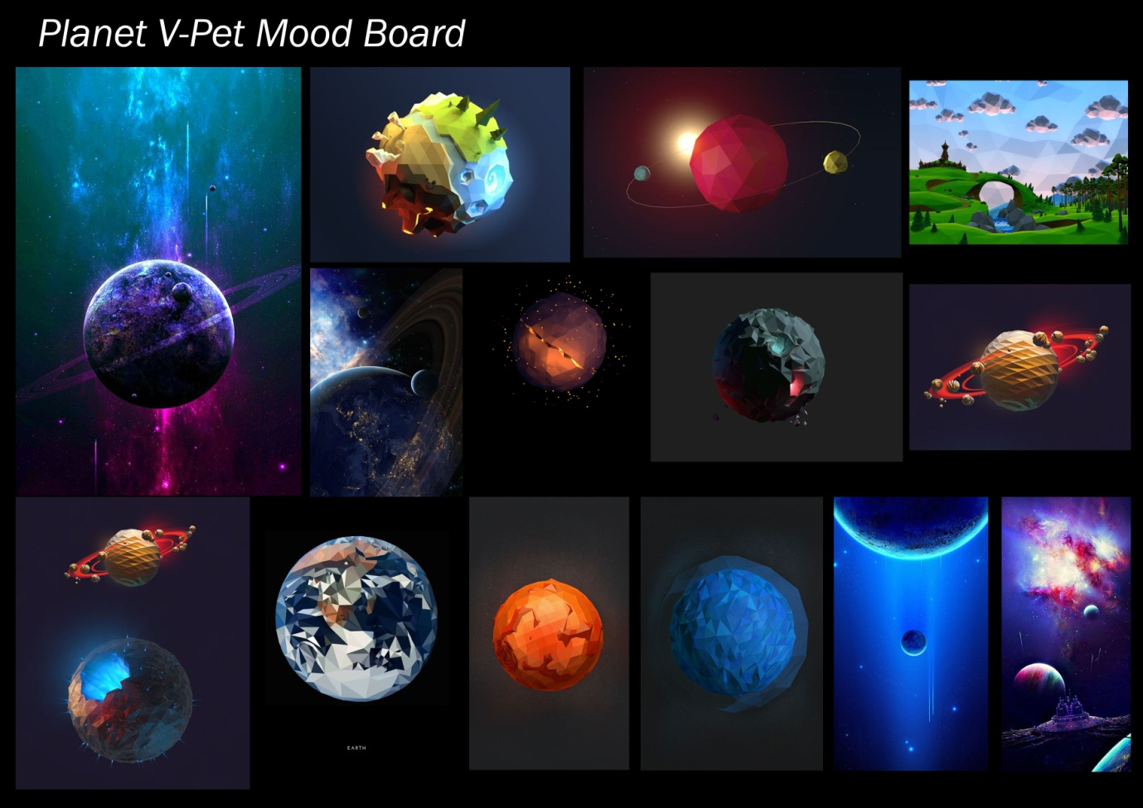

* Low poly count planet designs.
* Emmesive lights to generate awe and wonder.
* Flat colours (Possiblity to experiment with textures).

Mock ups :

|  |  |
| --- | --- |
| Earth2.png | * Low poly design : suitable for mobile devices. * Flat colours. * Minimal terrain. |
| Earth3.png | * Emessive colours. * Abstrct ‘alien’ designs (awe and wonder) |

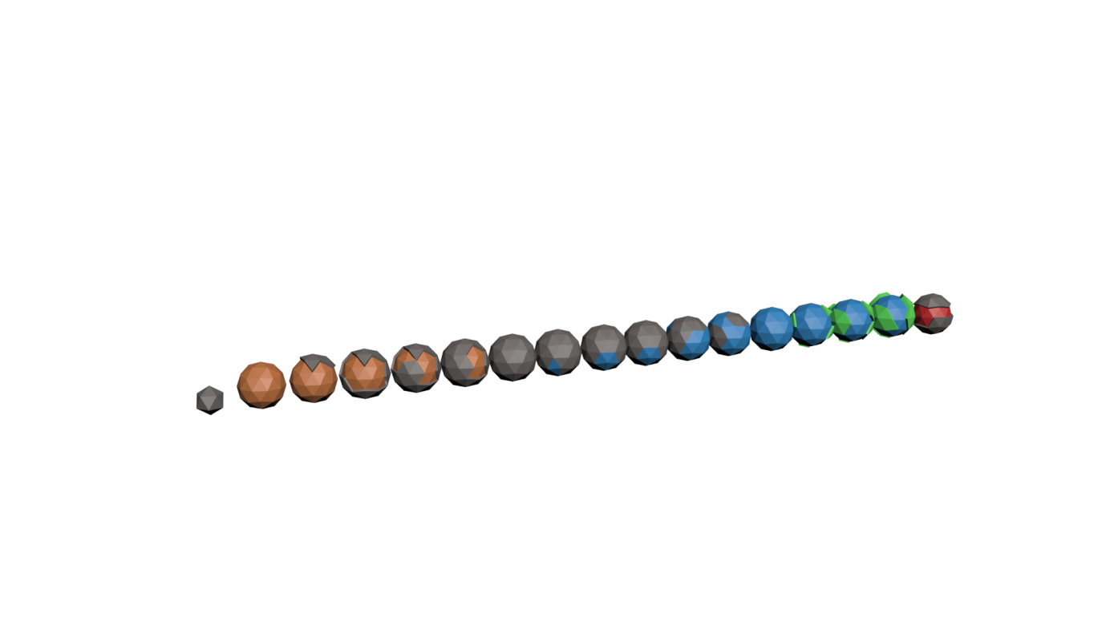

Planet stages concept (from right to left, astriod to dead planet)

Style guide:

